Alex Gibbons

March 21, 2024

CMPT 363 – Data Mining

Dr. Ankur Agrawal

library("tidyverse")

library("datasets")

head(iris)

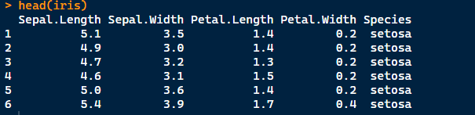

head(ChickWeight)

# as tibble function

# converts passed argument to a tibble

irises <- as_tibble(iris)

irises

chicken <- as_tibble(ChickWeight)

chicken

chicken <- rename(chicken, Weight = weight)

names(chicken)



filter(chicken, Diet == 2)

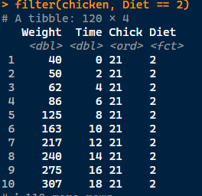

filter(irises, Sepal.Length > 5)

ggplot(data = chicken, mapping = aes(x = Time, y = Weight, color = Chick))

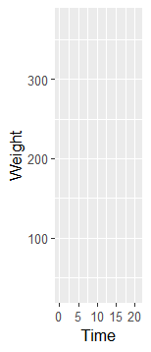

ggplot(chicken, aes(x = Time, y = Weight, color = Chick)) + geom_line()

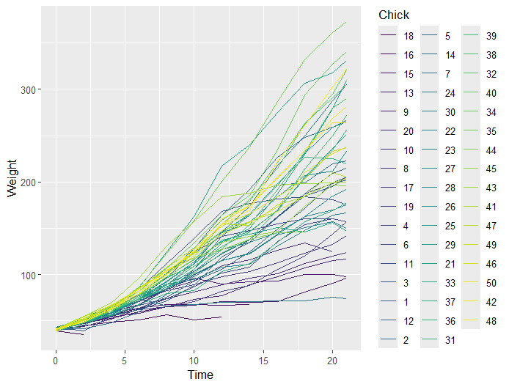

ggplot(irises, aes(x = Sepal.Length, y = Sepal.Width, color = Species)) + geom_point(size = 3)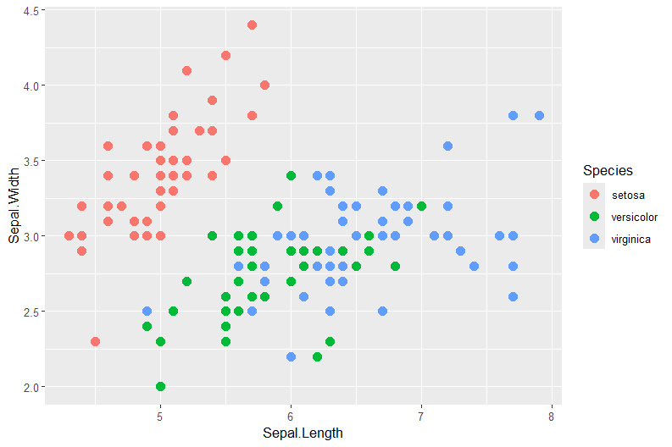

ggplot(irises, aes(x = Species, fill = Species)) + geom_bar()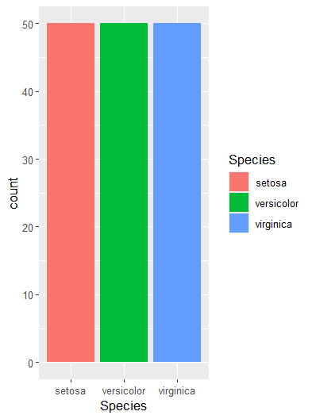

ggplot(filter(irises, Sepal.Lenght >5.5), aes(x = Species, fill = Species)) + geom_bar()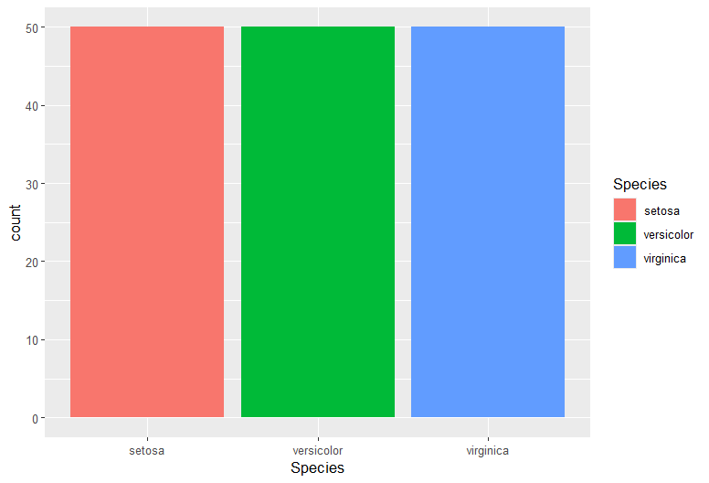

ggplot(irises, aes(x = Sepal.Length, y = Sepal.Width, color = Species)) + geom_boxplot()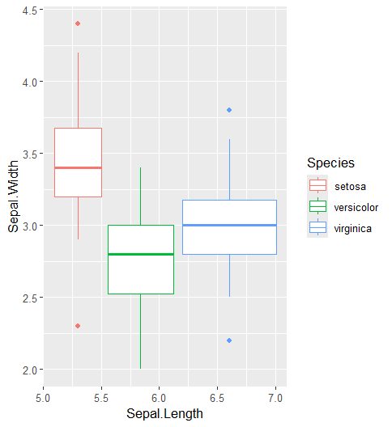

ggplot(irises, aes(x = Sepal.Length, fill = Species)) + geom_histogram(bins = 20)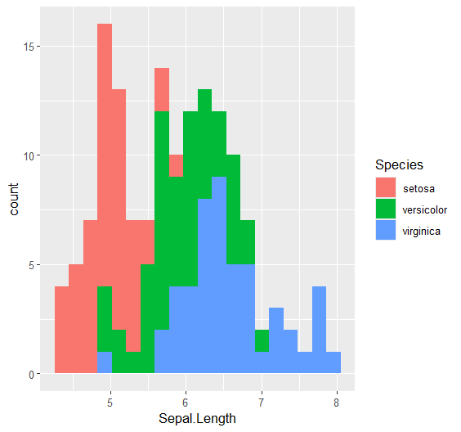

ggplot(irises, aes(x = Sepal.Length, color = Species)) + geom_density(size = 1)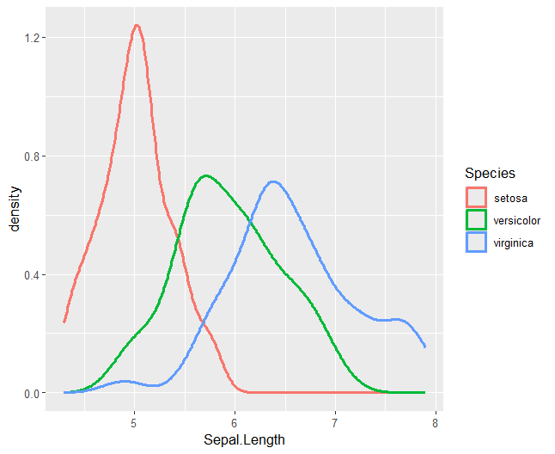

ggplot(irises, aes(x = Sepal.Length, color = Species)) + stat_ecdf(size = 1)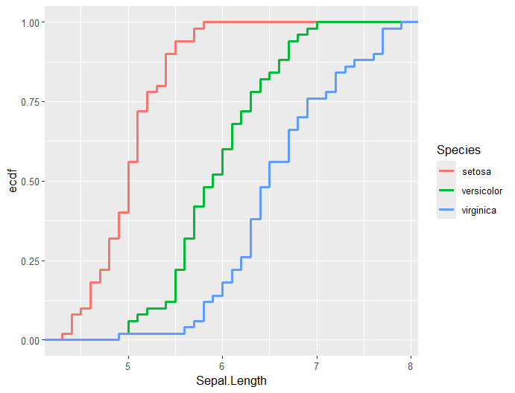

ggplot(irises, aes(x = Sepal.Length)) + stat_ecdf(size = 1)

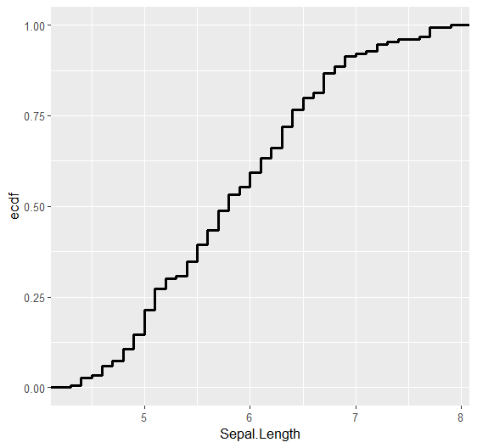

ggplot(data = chicken, aes(x = Time, y = Weight, color = Chick)) + geom_line() + geom_point()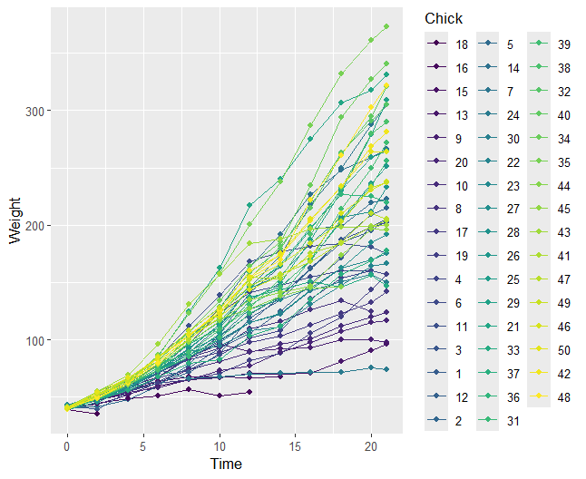

ggplot(chicken, aes(x = Time, y = Weight, color = Chick)) + geom_line() +

facet_wrap(facets = vars(Diet), nrow = 2, ncol = 2)